Step 3: Provide Instrumentation of the API (Observability)  
Following we provide the observability into the functioning of this REST application.

* Logging:

Spring Boot provides built-in support for loggin usging LogBack. We have both API request and JDBC session related information recorded in the log file. The log file will be created at ./logs/.

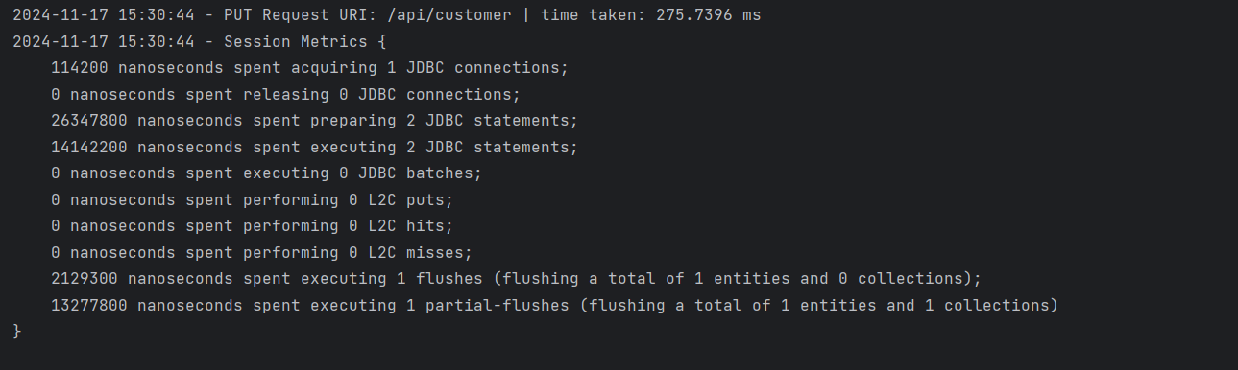

* Metrics:

We use Spring Boot Actuator to provide metrics endpoints that help monitor the API service health, performance and other details.

There are several endpoints available(for example, Prometheus):

http://{minikube-service-ip}:{service-port}/actuator/prometheus

http://{minikube-service-ip}:{service-port}/actuator/health

http://{minikube-service-ip}:{service-port}/actuator/metrics

http://{minikube-service-ip}:{service-port}/actuator/info

For example, we can see the information exposed by /actuator/prometheus

